Obtaining the SSP service manuals

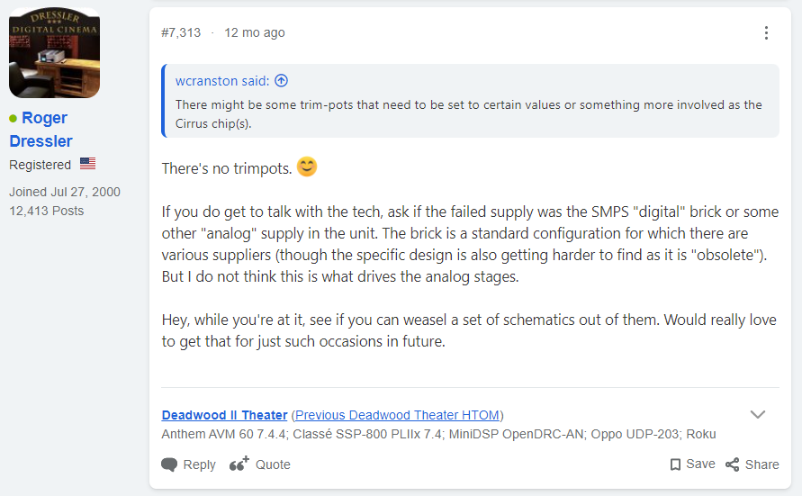

Oct 29, 2020

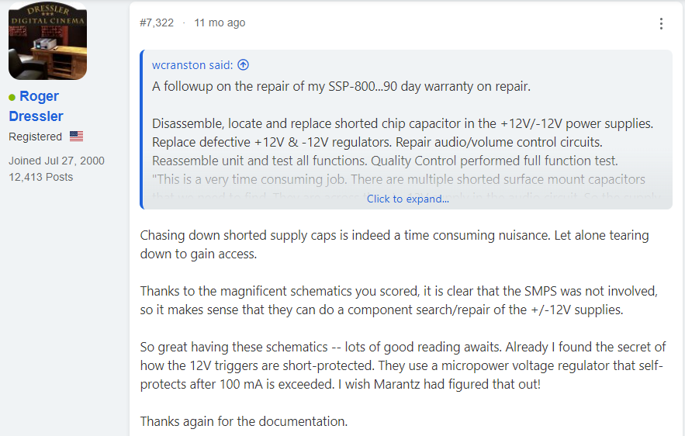

Nov 10, 2020